Development cycle

Stage 1
Features to implement
- Mouse controlled movement
- A prediction arrow for movement
- Collision detection (properly detects an object in contact)
- Set up variables and values for the player character

Design

Class diagrams

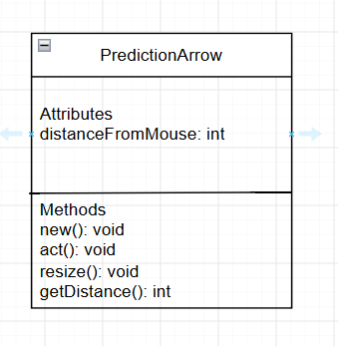
The main player character we will be using, containing a constructor, a move method (there’s an inbuilt one, but I’m making one beforehand as I know I will need to move all UI elements along with the player character at stage 5), a getter and calculation for velocity and a method that is used when the player collides with something.

The prediction arrow, edited according to where the mouse is from the player character, contains a setter, a resize method and a getter for the distance from mouse used for velocity calculations.

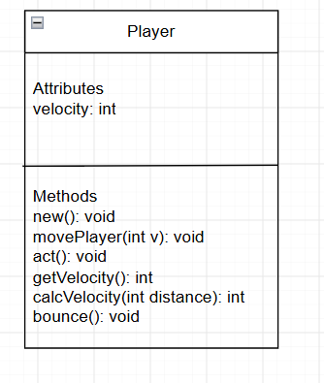

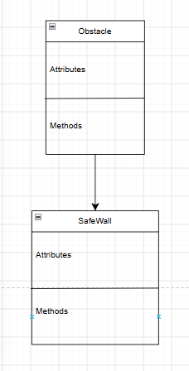
This is a temporary class made just for testing collision detection with the player, so there is no attributes or methods yet, this will be updated later.

